###### ------------------------------------------------------------------------------------------------------------

###### FRIENDS & CO

------------------------------------------------------------------------------------------------------------

Design document for

PARKOUR RAGE

"RUN FOR LIFE"

All work Copyright ©1987,2006 Friends & Co

Version 1.0

Written by Aishwarya,Bala,Vardhini,Mani SJ

Saturday, September 09,2014

Table of Contents

Design History-----------------------------------------2

Game Overview

Game Concepts----------------------------------------2

Feature set----------------------------------------------3

Genre----------------------------------------------------3

Target Audience----------------------------------------3

Look and Feel-------------------------------------------3

Project Scope--------------------------------------------3

Game Mechanics

Game Rule-----------------------------------------------4

Score Rule------------------------------------------------4

Speed Rule------------------------------------------------4

Game Objects---------------------------------------------4

Actions----------------------------------------------------4

Screen Flow----------------------------------------------7

Interface

Music------------------------------------------------------8

Camera----------------------------------------------------8

Artificial Intelligence------------------------------------8

Technical

Technical Hardware-------------------------------------8

Development Hardware and software-----------------8

Development procedure and standard-----------------8

Game Engine---------------------------------------------8

Scripting language---------------------------------------9

References------------------------------------------------9

Design History:

Version 1.0 is the creation of this game design documentation

(GDD).The basic framework of the documentation is created so that more information can be included more efficiently, with each section labelled.

Game Overview:

Game Concepts:

Parkour Rage is a jump based tactic game. Traceur,the player will be running to escape from the opponent(NPC).In the mean time the player will be collecting points on the way and doing stunts to earn high points. The game will be developed using Unity engine and run on android platform.

Feature Set:

* 3d game
* Single Player
* Fixed camera View
* 800*600 screen
* Dynamic Music

Genre:

Running Game

Target Audience:

Our ideal user has the following characteristics :

* Teenagers
* Has an Android Smartphone
* Likes Games especially Running.
* Play mobile games.
* Purchases content through apps or online

Look and Feel:

The focus of the game will be on the tactical decisions that the players need to make and because of the existence of reasonable random event,player would never feel bored.It's going to be full of excitement and fun loving.

Project Scope:

The game consist of a single location at present. The player will run indefinitely by performing actions[1] near randomized obstacle on the way until the player is caught(killed) by the Single NPC who will be chasing the player.

*Multiple locations will be added in later version of Game.

Game Mechanics:

Game Rule:

The only thing player(user) need to do is touching a specific area on screen to make the characters jumping.If the player is running slow in the game NPC who is chasing the player will kill the player.

Score Rule:

The score increases as time passes, and the increasing rate is based on player's current position. Collect special items on way to directly gain some score.

Speed Rule:

The player has a basic constant Speed throughout the game.

Game Objects:

Game object like help in getting more score. Each Star has 500points.

Game Actions:

The player perform below actions[1] in game.

* Single hand Vault 
* Two hand Vault 
* Cat Pass/Monkey/Kong Vault 
* Straddle Vault 

## Pop vault pop.gif

* Aerial 
* B-Twist 
* Heel Hook 
* Wall Run 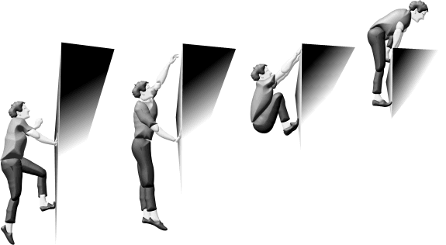

## Wall flip/back somersault wallflip.gif

* Barrel roll 
* Cat leap 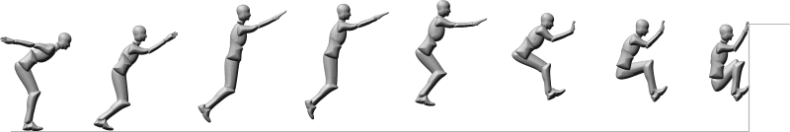
* Gap/Precision Jump 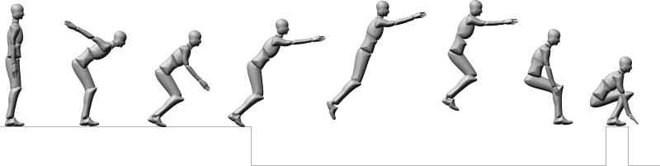

Screen Flow:

OFF

ON

Interface:

Music:TBD

Camera:TBD

Artificial Intelligence:

* Player enter game on left side followed by NPC.
* When the Player is nearing obstacles,the player will be performing stunts based on the obstucle distance to cross it.

Technical:

Targeted Hardware: Android devices

Development Hardware and Software:Unity3D,3dMax

Development Procedure and Standard:

SCRUM using Trello.

Game Engine:Unity 3D.

Scripting Language:JavaScript

References:

http://www.ivencia.com/index.html?/dynamicarts/routes.htm